“A Unique Sense of Place”
48144 Basargin Road
Homer, Alaska 99603

Owner: Robert Chew, Boulder Colorado
Robert.chew@cagents.com/ Robert.chew@mac.com
+1 317 710 1530

Emergency and other support
Call 911 and provide the above address.
Fire department: 907 235 3155
Police department: 907 235 3150
Neighbors in Razdolna, Nick and Stephanie Basargin 907 235 9464 (home) / 907 399 3066 (cell)
Property Manager Domnica Kalugin 907 299 5891

There are minor first aid items (band-aids and such) under the little wooden stand to the left of the refrigerator/freezer.

Cell service may or may not available at the house (Verizon, yes; AT&T, no); there is the ability to make calls via internet wifi calling. Weak cell signals can usually be obtained by driving about a mile further down Basargin road to the village of Razdolna.

Getting There
See separate pages with details. Drive out East End Road. At around mile 18.9, there is a wide dirt road to the left, Basargin Road. Go 3.6 miles and house is on left.

NOTE: THE LAST 15 MINUTES OF YOUR JOURNEY YOU WILL NOT HAVE CELL SERVICE

The keys are in a lockbox on the front door. Press Clear, then the code, then Open. Lockbox code is 27183. You must re-enter the code in order to close the lockbox. Depending on time of year, you may need to lift up slightly on the door handle to get the deadbolt to turn or to latch it shut. This is due to weight of door and thermal expansion of house and door. If you are stuck outside, there is a spare key to the basement door in a little space near front corner under deck next to house.

Temperature and Ventilation
There are individual thermostats for each bedroom. There is a thermostat in the great room main floor and a thermostat for the lower level common areas. Thermostat operation is self-evident.

Heat is provided through the floor. It provides a nice warm floor, but it can take a long time to heat up the house. If the house is cool, the fireplace with its blower can contribute significantly to a faster heatup. Passive solar heating on a sunny day can be a major source of heat, and in the summer will need to be dissipated via open windows and a breeze.

Cooling is through open windows. Do not open them very far in case of a sudden high wind gust which could rip open a window and blow it away.

There is a heat recovery system which provides fresh air circulating throughout the house. The controls are adjacent to the great room thermostat. There is a program (PROG) that is for energy efficiency. Pressing the Mode button changes to either VENTilate or RECIRCulate. You should not need to change the mode (windows work better), but if you do, please return the system to PROG before you leave. Otherwise it will waste energy.

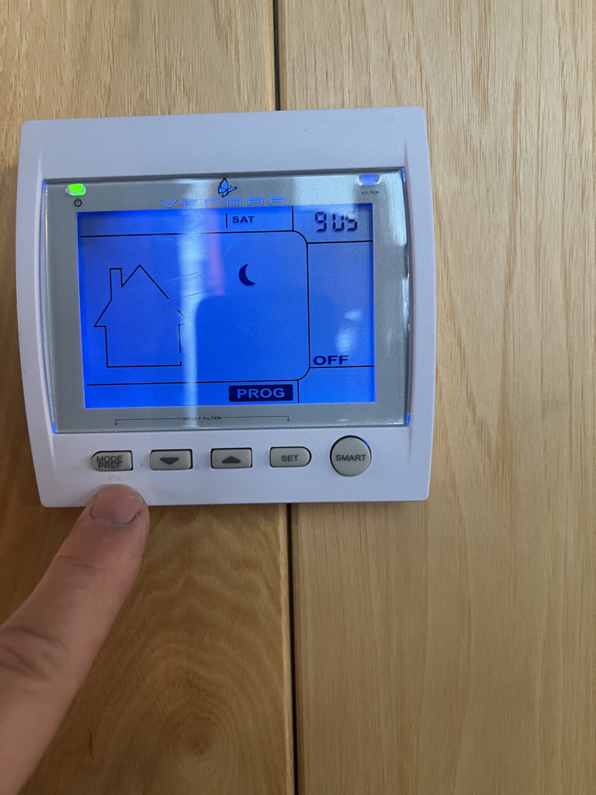

Lights
Lighting is pretty simple. There are several sets of lights on dimmers that allow one to set a “mood” in the great room and the brandy loft. The wall candle lights in each room, and a set of ceiling lights in the great room can be adjusted to set a mood. Please be judicious with the outdoor lights in order to minimize light pollution in this natural wilderness area.

Water
Water supply is from a well behind the house. The ground water flowing into the well provides water at a certain rate and the well pump has a maximum capacity. The domestic water system is engineered to (a) treat the well water and (b) provide for constant supply. However, it does have limitations. If everyone flushes toilets at the same time while someone is taking a shower upstairs, water pressure might drop to near zero for a brief time.

WIFI
There is no password necessary for the wifi connection. WIFI is via satellite, and when the satellites shift from one to another, the connection can become weak or can be broken for a few seconds. There are three networks. Robert Chew’s network works best in the lower level. WIFI_F1EA and WIFI_F1EA-5G work best on main and upper levels.

Operation of the stove is self-evident. The left smaller oven is a baking oven. The right oven has a gas broiler which does wonderful steaks; it also has a convection feature. Operation of the hood generally is better if there is a window open somewhere (kitchen sink window works best) as the house is quite tight otherwise.

Please ensure all burners are turned off after use. Also, please ensure you turn off the convection fan before turning off the right oven. If you leave the fan on, it tends to pop the circuit breaker rendering the stove inoperative (if this occurs, the breaker box is in the far right storage room in the lower level – just reset the stove breaker).

The kitchen sink has two buttons on the lower right side of the cabinet. The smaller upper button can be pushed to start hot water circulating through the pipe loop, making it hot and ready when needed. The lower larger button is for the garbage disposal that is on the right sink drain.

I generally just use the 1-hour wash cycle with the dishwasher. The regular cycle takes several hours.

If you use the grill that is out on the deck (summer only), it MUST be cleaned after each use, and any grease catch brought inside. Meat and fish odors have a tendency to attract bears or other unfriendly animals. As this grill is new for 2019, I have no experience with its effect on the wider environs and inhabitants thereof.

DO NOT LEAVE ANY TRASH OUTSIDE!!! IT WILL ATTRACT UNWANTED LARGE FURRY CREATURES!

Wine and Liquor
You are welcome to use anything in the wine cooler. Please replace with something similar (variety and quality). You are welcome to the other liquor as long as in modest moderation (or replace in kind if significant use). Please report any bottles that are close to empty so it can be replaced.

Smoking and Open Flames
Smoking, with care, is only permitted on the covered porch area. Do not smoke on the open deck. A few years ago someone was sharpening a shovel in their backyard, some sparks hit the grass, and 50,000 acres of the Kenai Peninsula were burned. A stray cigar or cigarette ash could have the same result. The covered porch has a gravel driveway below as a fire “barrier” although even there, weeds can grow that become flammable. Smoke there with care! And dispose of cigarette butts in trash, DO NOT FLICK or THROW AWAY OUTDOORS!

Please limit open flames to lighting the fireplace, operating the stove, and lighting candles in the lower level bathtub area. No candles, incense or other open flames anywhere else inside the house.

Toilets and Trash Disposal
Nothing in toilets except human waste and associated toilet paper. Everything else (feminine products etc.) goes into trash.

Store trash in house – under stairs in lower level if you need to. Take trash to dump near McNeil Canyon Elementary School (see driving directions for location). DO NOT store trash outside as it will attract unpleasant large furry wild things!

There is no daily maid or cleaning service, only cleaning will occur after you depart.

Fireplace and woodpile
Newspaper and a bit of fine kindling is in the entry closet in a box. Matches are in the kitchen drawer with silverware. Please keep air to fire box full (lever to far right). This results in a hotter fire which prevents a black soot from forming on the glass – and which would require substantial elbow grease to remove! The rheostat switch on the right side of the fireplace operates the blower. But you must have a hot fire going for awhile (20 – 30 minutes) before the box heats up enough to trip the thermostat that enables fan operation.

Deck Furniture
If not on the deck already, there should be three folding deck chairs in canvas bags in the entry way closet for your use. They are stored there out of the weather so they aren’t wet when you want to enjoy the view. There are also blankets for your use, stored in the upstairs bookshelf or folded on a leather chair.

Weather
Weather.com is not accurate ever. NOAA weather forecast is better. Weather is usually better than what is advertised. Temperature at the house is generally 5 deg F warmer than Homer in summer, and 5 deg F colder in winter. If you don’t like the weather, wait a couple hours and it will likely change.

Rainy days
There is a pool table and a Smart TV for internet streaming. No cable and no satellite TV (but there is satellite internet. There is a chessboard and Scrabble and two decks of cards. There are puzzles and books and magazines in the bookshelf upstairs in the Brandy Loft. Or just sit and have quiet conversation with family and friends, or enjoy solitude and contemplate the universe!

Hiking
You can take a simple stroll across the road, which is still my property. Walk west to the edge of the canyon, but be careful! You can stroll through wildflowers and see mountains and glaciers.

You can walk straight back (north) from the house, across Willards road and continue back, although it may be very wet, almost marshy back there. And mosquito laden!

You can walk up Willards road to the northeast, and after about ¾ mile you’ll hit the Caribou Lake parking area. From there, you can hike 10 km to Caribou Lake, although it can be wet and muddy unless there has been a long dry spell. Know that there are moose, bear, wolves and coyotes along the way.

Winter
If you brought your snowmachine, you’ll know what to do. Endless terrain for 50 miles!

I like to cross-country ski, heading north from the house. But you must know how to navigate without your phone assistant! Don’t get lost! And there are moose, coyotes, bear and possibly wolves out there.

Cautions and items of note:

This house is in good condition and effort is made to keep it that way. It is there for people to relax and rejuvenate and bond with family and friends. Do not have wild parties. Be respectful of the house – so others can enjoy what you are enjoying.

Do NOT cut directly onto the wood countertops!!!! I once had a personal guest do that and there are two small cuts evident on the countertop by the dishwasher. Don’t do any more or the damage deposit will be assessed!

DO NOT place hot things directly onto the wood surfaces. That will discolor the surface and result in a damage assessment!!!

DO NOT use abrasive materials on the wood surfaces. That will scratch the surface and result in a damage assessment!!! Windex or Pledge and a soft towel or paper towel works to clean these surfaces.

DO NOT bring pets – house rules prohibit pets. If you bring pets, the cleaning crew will know and you will be rated low on “following house rules.” If your pet damages the house, such as scratching a leather chair, you will be charged for damages as well.

Please help us maintain the pool table in working condition by protecting the red felt!!! Keep children (and irresponsible older people) away from the pool table. Do not put drinks etc. on the rim of the table. If there is a tear in the felt, you will be charged the repair fee and it won’t be cheap! Don’t play pool if guests are inebriated. If the tip of a cue stick comes off, there is a repair kit in a small drawer of one of the tables in the pool room.

Regional
Check out these activities:
- Fishing from a boat in Cook Inlet (halibut or salmon)
- Fly fishing in many rivers up the Kenai Peninsula
- Take a float plane or boat across Kachemak Bay and go hiking. There is a book on this subject in the upstairs book shelf.
- Take a float or wheeled plane to go bear viewing in Katmai or Lake Clark parks.
- Take a float plane to Brooks lodge or Kulik Lodge or Grosvenor Lodge: fishing, overnight lodging or bear watching. From Brooks Lodge you can take a bus (all day trip) to the Valley of Ten Thousand Smokes – site of largest volcanic eruption of the 20th century.
- Charter a light plane to take a flight-see over the Harding Icefield.
- Explore the Homer Spit
- Check out the Islands and Oceans Wildlife Refuge Visitor Center

My favorite restaurant is Captain Pattie’s on the Homer Spit, across from Coal Point Trading Company (which sells king crab, king salmon and other seafood). There is also Fresh Catch Café which is good. However, both of these are only open in the late Spring and Summer months. The restaurant at the Land’s End Resort at the far end of the Homer Spit is decent and open year round (and they have a nice deck with a stunning view when the weather is nice). Then there is the world-famous Salty Dawg saloon, near the end of the Homer Spit.

Lastly, you can buy just about any non-food item at Ulmer’s Drug Store/ True Value Hardware (one store) located in town. A couple miles out East End Road is the Gear Shed if you need rain gear, warm clothing, etc.

For Your Use
Down in the lower level is a storage room. There is a Coleman cooler and four rain ponchos. Feel free to use, but please clean after use. Upstairs in the Brandy Loft is a bookshelf. On the bottom shelf are three binoculars. Please feel free to use but handle with due care.

Telescope
If you know about telescopes, you are welcome to use the 12” Dobsonian that I have. There is a laser for alignment (three thumb screws on bottom of scope tube adjust the mirror). There are 3mm, 10mm, and 25mm eyepieces, although not very good. I bring better ones with me when I plan to view (September – March is better due to having real darkness).

Food and Wine
Safeway or Save-U-More in Homer for groceries. Coal Point Trading Company on the Homer Spit for seafood to take home and cook, including THE BEST king crab EVER! Grog Shop in center of Homer for good selection of wine and spirits.

Spare Stuff
- Spare towels in upstairs linen closet and lower level bathtub area.
- Spare toilet paper in upstairs linen closet and in storage under stairs lower level.
- Spare paper towels in pantry.
- Additional cleaning supplies and more paper towels in storage under stairs lower level.

Quirks, Tips and Helpful Hints
The heavy front door often requires you to lift up on the door handle to get latch to engage or to allow key to turn bolt. This is seasonal and is a result of thermal expansion/ contraction of house vs. door.

If you operate the stove griddle, after you turn it off and the back begins to cool, you’ll hear a big bang from the metal contracting.

If you operate the ovens (which are gas), you’ll hear a “whomph” whenever the oven turns on to maintain desired temperature.

There are three ways to enjoy coffee:
- Drip coffee maker
- French press – use teapot to boil water and pour onto grounds in the glass container, then press down on the lid to push grounds to bottom. This is my favorite.
- Espresso pot. There is a small metal pot with lit that has a milk frothier. To make cappuccino or lattes, heat milk in a small saucepan and then use frothier to make it foamy.

Please keep air to fire box full (lever to far right). This results in a hotter fire which prevents a black soot from forming on the glass – and which would require substantial elbow grease to remove! The rheostat switch on the right side of the fireplace operates the blower. But you must have a hot fire going for 20 – 30 minutes before the box heats up enough to trip the thermostat that enables fan operation.

The bathtub in the lower level is huge, and the capacity of the hot water heater can be “maxed out” when filling the tub. I’m working to adjust the boiler settings to improve this, but don’t be surprised if you run out of hot water when filling the tub to a great extent.

I once arrived at the house to find the power out. It turned out that there was no power to a large section of the Kenai Peninsula. Another time the stove wouldn’t light – turns out the breaker was open. The breaker box is in the storage room far right corner of lower level.

Do not open windows more than an inch or two when windy – and it can become windy quickly. Take care when opening storm door to deck or lower level if windy – wind can whip those wide open in an instant.

The well water is run through two filters in series and then a water softener. After significant use, the filters get clogged and need replacing. Replacement filters are in the utility room, but you shouldn’t have to do this. Note: the filters only can pass a certain flow without causing substantial pressure drop. If you try to take a shower upstairs while using lots of water to fill bathtub or toilets or sinks, you may be disappointed.

I have slept in the house perhaps 160 nights over the past 15 years. During that time I have felt two fairly substantial earthquakes – enough to awaken me out of a sound sleep. The last was a 5.8, epicenter 61 miles SSW of Homer in May 2019. So far the house has been like a rock – no damage. But don’t be surprised if you experience one.

Please maintain control of kids and irresponsible adults – don’t carve initials or otherwise damage the fine woodwork throughout the house. Your damage deposit will be assessed to repair this sort of damage.

DO NOT LEAVE ANY TRASH OUTSIDE!!! IT WILL ATTRACT UNWANTED LARGE FURRY CREATURES!

DETAILED DRIVING DIRECTIONS

NOTE: THE LAST 15 MINUTES OF YOUR JOURNEY YOU WILL NOT HAVE CELL SERVICE. DON’T COUNT ON YOUR PHONE TO PROVIDE DRIVING DIRECTIONS!!!

Drive out East End Road from center of Homer (Pioneer becomes East End heading east out of town). After about 13-14 miles, as you crest the ridge after a long uphill you’ll pass a volunteer fire station and then McNeil Canyon Elementary school, both on your left. Take note – a couple hundred yards later is Old East End Road to the right. This is where the trash gets dumped upon your departure or as needed.

A couple miles further you’ll likely lose cell phone coverage (right around milepost 15 – the first milepost you’ll see). But the views are great and worth the drive! You then head downhill and into a section of windy road.

After milepost 18, you’ll soon be heading uphill and away from the bay.

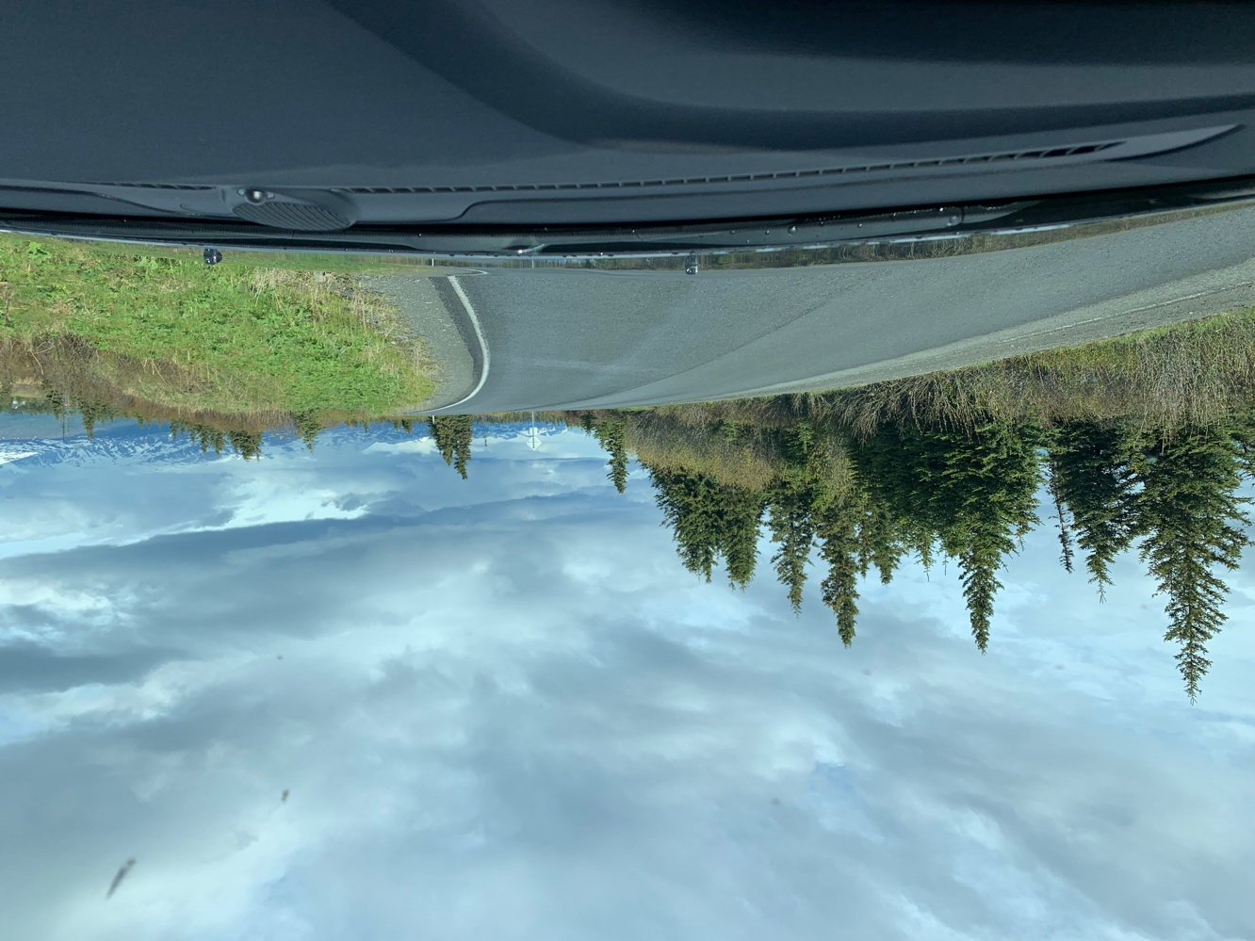

As you climb a hill with right curve, just after the crest there is a wide dirt road to the left, Basargin Road. See picture. If you pass 19 milepost, you’ve gone a bit too far.

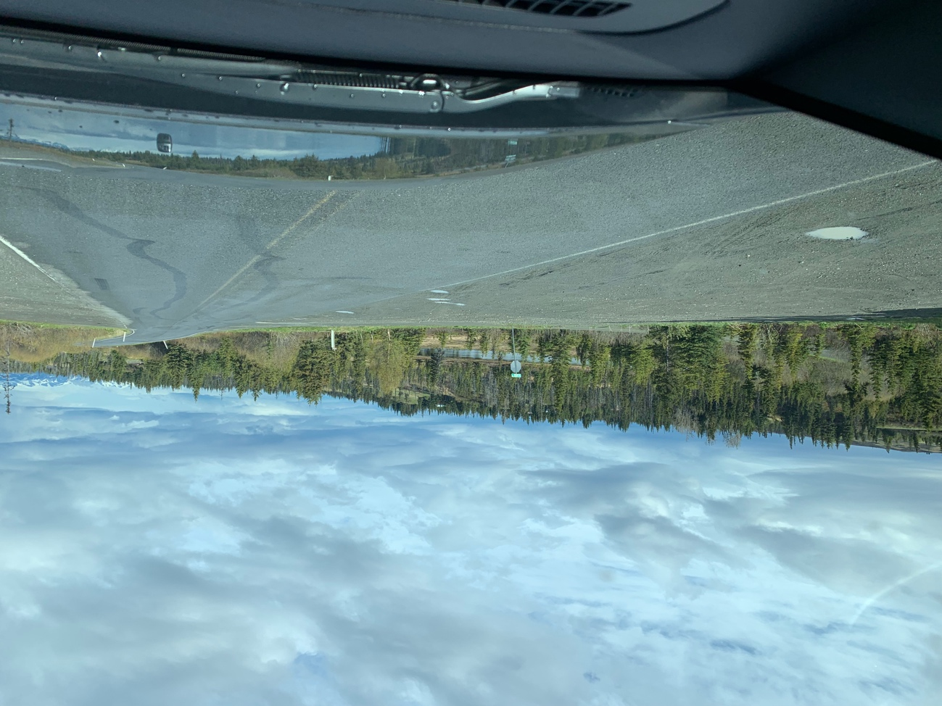
Basargin Road to left

Turn onto dirt road and follow it for 3.6 miles. As you drive this road, you might begin to doubt the choice of rental you’ve made. Fear not! It will be worth the quiet solitude and comfort of the house.

You will pass three roads that each run off to the left:
- Totem Pole, at mile 0.9
- An unmarked road that heads uphill to a gravel pit, at mile 1.5
- Willards Road (shown below), to Caribou Lake trailhead, at mile 3.5. As you pass this road, you will now be on my land.

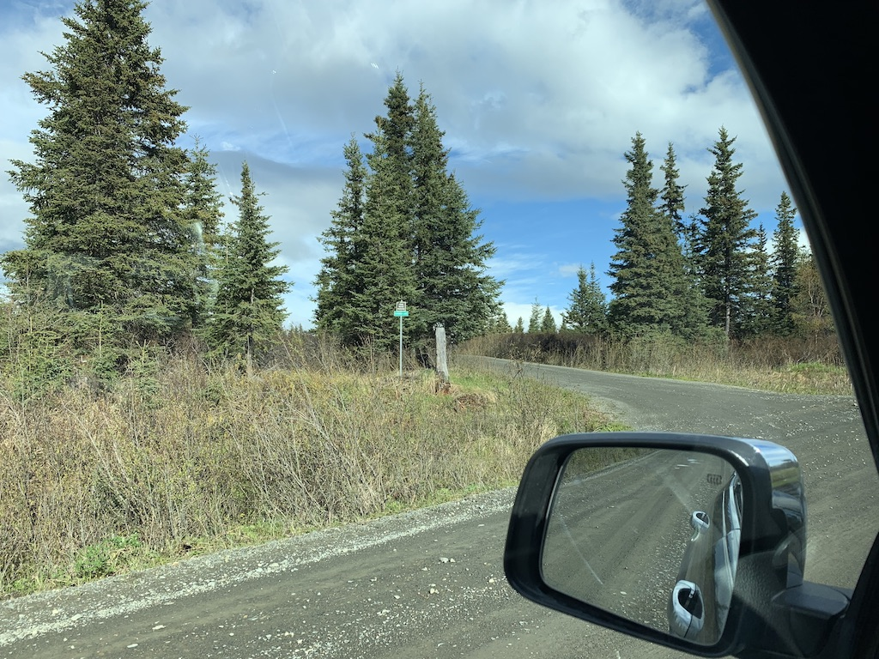
Willard’s Road to left. Willards road also divides my land into a “north 40” and a “south 40” acres.

Drive 250 yards further to crest a hill, with a view of glaciers staring you in the face. The driveway is on the left just after cresting the hill. The house is the first house you will have encountered on Basargin road.

The house does not look very big from the outside, but I assure you you’ll be amazed when you step inside.

The keys are in a lockbox on the front door. Press Clear, then the code, then Open. Lockbox code is 27183. You must re-enter the code in order to close the lockbox.

Depending on time of year, you may need to lift up slightly on the door handle to get the deadbolt to turn or to latch it shut. This is due to weight of door and thermal expansion of house and door.

If you are stuck outside, there is a spare key to the basement door in a little space near front corner under deck next to house.

Final 250 yards before house, just after Willards road goes off to left.
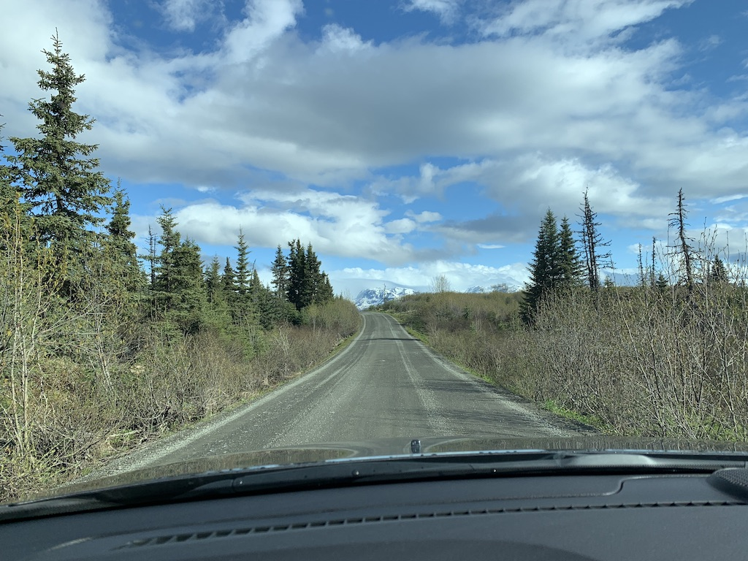
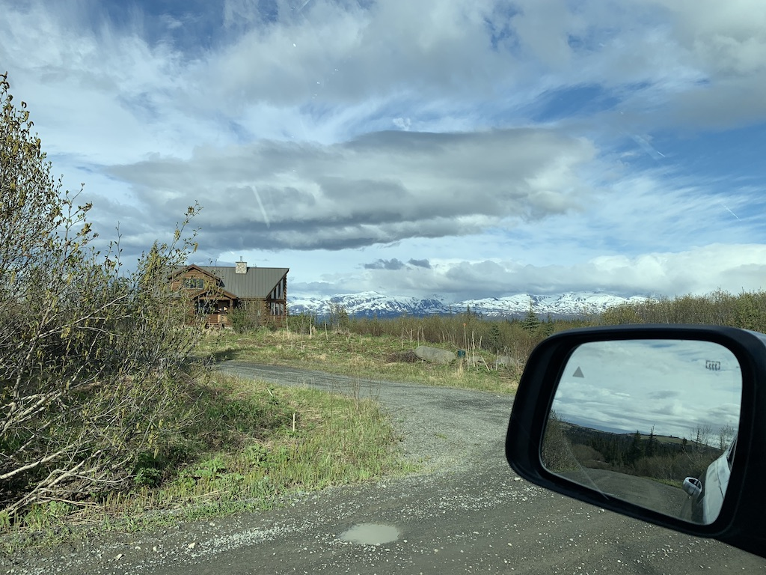
Red rectangle is property boundary. Note that Willard Road has been re-routed – see red text.
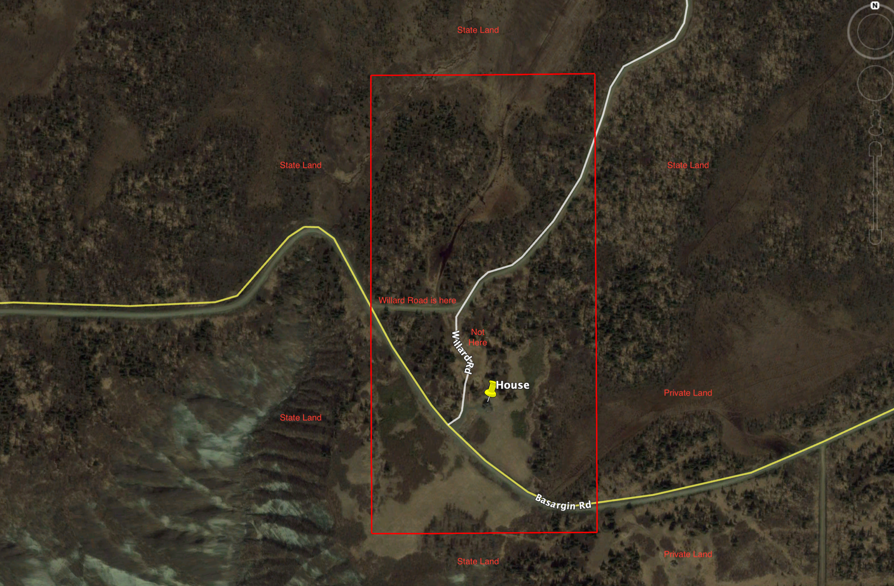
Private land is to the southeast. State land surrounds the rest of the property

